# How to populate Report Configuration data

# What you need –

* Go to p4//prod_depot/artifacts/datamart-integration/
* Copy chart-config directory to you working directory

1. Use **sqlplus** for Oracle or **db2cmd** for DB2 to run the insert script (REPORT_INSERT_SCRIPT.sql) under the chart-config directory and import the chart configuration data into the C_REPOS_RPT_CONFIG table of your target ORS.

# How to Setup and Run Datamart Population Utility

# What you need –

* Go to p4//prod_depot/artifacts/datamart-integration/
* Copy populate_datamart.jar, config and lib directory to you working directory

# Open command prompt in your working directory

1. Run the following command

java -jar populate_datamart.jar config

This will start the configuration process

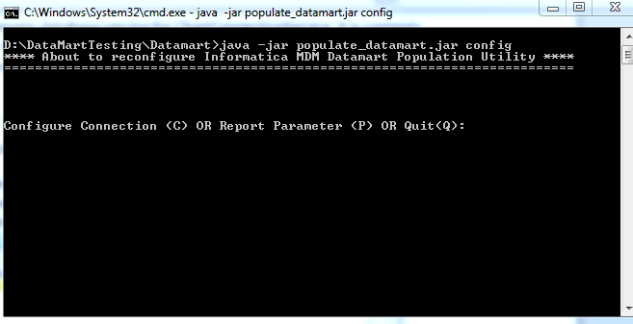

1. Type C or P to configure either a Database connection or a Report parameter.

**Following parameters are to be entered for setting up a Connection**

|  |  |
| --- | --- |
| Connection Name | Unique name for the connection. In case the name exists it will be overwritten. |
| Type of Connection | Currently on DB is supported |
| Database vendor | Oracle, DB2 etc. |
| User | Database User |
| Password | Database Password |
| Token | Not used |
| Host Name | Database hostname |
| Port | Database port |
| Database Name | Database name/ SID |

**Following parameters are to be entered for setting up a Report Parameter**

|  |  |
| --- | --- |
| Report Name | Unique name for the report. In case the name exists it will be overwritten.  NOTE: always use valid report names. Available report names can be found in “**\config\report-class-mapping.properties**" file. |
| Report Configuration ID | Report configuration id for the report (as exists in the c_repos_rpt_config table) |
| Mart Connection Name | Connection name for connecting to the data-mart |
| Query Connection Name | Connection name for the database to be queried |

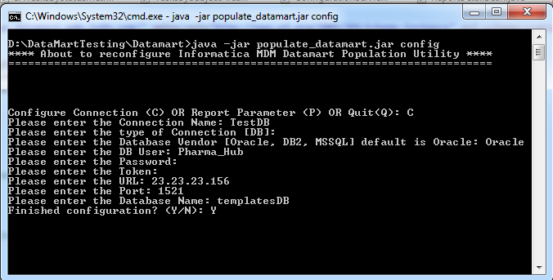

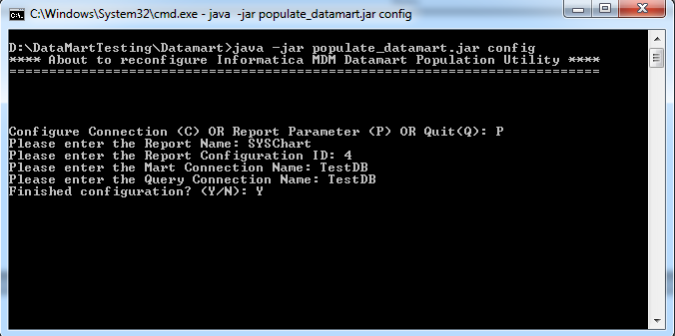

1. You can either enter Y to finish configuration or enter N to continue.
2. mart-population-config.xml file will be generated in the config directory

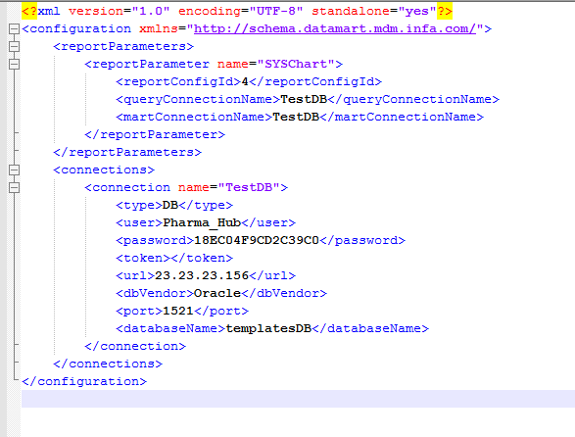

1. To execute all report or any specific report run

**java -jar populate_datamart.jar exec** (for executing all available charts)

**OR**

**java -jar populate_datamart.jar exec <report_name>** (for executing selectively)

